Windows application -- Core Java --

Web Application - Adv. Java - Servlet / Jsp --- Tomcat server -Eclipse --

Frameworks : Architecture : RoadMap : service layer

Spring Framework -- Bean class - Entity -- getter / setter / toString()…..

Spring Boot Framework : @Data -- Lombok

Hibernate Framework : Database/ Backend

Microservices :

Spring Project / Spring Boot Project

Building a project : Maven Build Tool ( Through out project life cycle ) / Gradle Build Tool

For that we need some jar files -- executable jar files contains compiled classes (byte code ):

Maven repository ( Central Repository) : Dependencies -- POM.xml --- Remote Repository --- Local repository -- .m2 folder

/get

viewDate() --- Mockito

/post

addDate()

/delete

Postman / SoapUI / Swagger Doc

IOC -- Inversion of control

Com.hcl.controller

Com.hcl.bean /pojo/entity

Com.hcl.repository

Com.hcl.service

Spring boot - no. of annotation

@Entiry

@Service

@Controller

Microservices : Micro + Services

Architecture of an application :

Monolithic Architecture : All modules exist in one application -- Bnk related application

1. Bank A/c -
2. Loan A/c
3. Pension

20 / modules

Drawback :

a) coupled with each other

b) debugging challenge

c) Time complexity / Code complexity

1. Load on server
2. no modularity
3. Limited scalability --- Upgradation - costly
4. Deployment challenges

Microservices Based Architecture -- collection of small, loosely coupled services. Each service is self-contained and implements a single business capability. These services communicate with each other through well-defined APIs over HTTP.

BANK A/c ----

Loan A/c --

Advantages :

1)Services will run on different port no's hence there will be less dependency , loosely coupled

1. Circuit Breaking
2. Load Balancer

Disadvantages : resources are costly :

SWIGGY
Ink Drawings
Ink Drawings
Ink Drawings
Haldiram
client
Ink Drawings
Ink Drawings


|  |  |  |  |  |  |
| --- | --- | --- | --- | --- | --- |
|  |  |  |  |  |  |
|  |  |  |  |  |  |
|  |  | Domino |  | Eatery Royale |
|  |  |  |  |

Ink Drawings
Ink Drawings
Spring Boot -- Project
Controller --- Swiggy  (API) -- / halidram , /Domino , / Eatery Royale

Pojo

Service : a) Domino.java B) Halidram c) Eatery Royale
Ink Drawings
Ink Drawings
Ink Drawings
Ink Drawings
Ink Drawings
B2B
RestController

Interface 
One method  -- findAll()
Default 
static


Microservices







Ink Drawings
Ink Drawings
Ink Drawings
Ink Drawings
Ink Drawings
Ink Drawings
Ink Drawings
Ink Drawings
Ink Drawings
Ink Drawings
Ink Drawings
Ink Drawings
Ink Drawings
Ink Drawings
Ink Drawings
Ink Drawings
Ink Drawings
Ink Drawings
Ink Drawings
Ink Drawings
Ink Drawings
Ink Drawings
Ink Drawings
Ink Drawings
Ink Drawings
Ink Drawings
Ink Drawings
Ink Drawings
Ink Drawings
Ink Drawings
Ink Drawings
Ink Drawings
Ink Drawings
Ink Drawings
Ink Drawings
Ink Drawings
Ink Drawings
Ink Drawings
Ink Drawings
Ink Drawings
Ink Drawings
Ink Drawings
Ink Drawings
Ink Drawings
Ink Drawings
Ink Drawings
Ink Drawings
Ink Drawings
Ink Drawings
Ink Drawings
Ink Drawings
Ink Drawings
Ink Drawings
Ink Drawings
Ink Drawings
Ink Drawings
Ink Drawings
Ink Drawings
Ink Drawings
Ink Drawings
Ink Drawings
Ink Drawings
Ink Drawings
Ink Drawings
Ink Drawings
Ink Drawings
Ink Drawings
Ink Drawings
Ink Drawings
Ink Drawings
Ink Drawings
Ink Drawings
Ink Drawings
Ink Drawings
Ink Drawings
Ink Drawings
Ink Drawings
Ink Drawings
Ink Drawings
Ink Drawings
Ink Drawings
Ink Drawings
Ink Drawings
Ink Drawings
Ink Drawings
Ink Drawings
Ink Drawings
Ink Drawings
Ink Drawings
Ink Drawings
Ink Drawings
Ink Drawings
Ink Drawings
Ink Drawings
Ink Drawings
Ink Drawings
Ink Drawings
Ink Drawings
Ink Drawings
Ink Drawings
Ink Drawings
Ink Drawings
Ink Drawings
Ink Drawings
Ink Drawings
Ink Drawings
Ink Drawings
Ink Drawings
Ink Drawings
Ink Drawings
Ink Drawings
Ink Drawings
Ink Drawings
Ink Drawings
Ink Drawings
Ink Drawings
Ink Drawings
Ink Drawings


Fault Tolerance

Cascading Failure :

where the failure of one microservice can propagate through system, causing other microservices to fail as well.

Fault Tolerance:

Gracefully handle errors, failures , or any unexpected events without compromising its overall functionality .

Ink Drawings
Ink Drawings
Ink Drawings
Ink Drawings
Ink Drawings
Ink Drawings
Ink Drawings
Ink Drawings
Ink Drawings
Ink Drawings
Ink Drawings
Ink Drawings
Ink Drawings
Ink Drawings
Ink Drawings
Ink Drawings
Ink Drawings
Ink Drawings
Ink Drawings
Ink Drawings
Ink Drawings
Ink Drawings
Ink Drawings
Ink Drawings
Ink Drawings
Ink Drawings
Ink Drawings
Ink Drawings
Ink Drawings
Ink Drawings
Ink Drawings
Ink Drawings
Ink Drawings
Ink Drawings
Ink Drawings
Ink Drawings
Ink Drawings
Ink Drawings
Ink Drawings
Ink Drawings
Ink Drawings
Ink Drawings
Ink Drawings
Ink Drawings
Ink Drawings
Ink Drawings
Ink Drawings
Ink Drawings
Ink Drawings
Ink Drawings
Ink Drawings
Ink Drawings
Ink Drawings
Ink Drawings
Ink Drawings
Ink Drawings
Ink Drawings
Ink Drawings
Ink Drawings


|  |  |  |  |  |  |  |  |  |  |  |  |  |  |  |  |  |  |  |  |
| --- | --- | --- | --- | --- | --- | --- | --- | --- | --- | --- | --- | --- | --- | --- | --- | --- | --- | --- | --- |
|  |  |  |  |  |  |  |  |  |  |  |  |  |  |  |  |  |  |  |  |
|  |  |  |  |  |  |  |  |  |  |  |  |  | Ink Drawings Ink Drawings Ink Drawings Ink Drawings Ink Drawings Ink Drawings Ink Drawings Ink Drawings Ink Drawings Ink Drawings Ink Drawings Ink Drawings Ink Drawings Ink Drawings Ink Drawings Ink Drawings Ink Drawings Ink Drawings Ink Drawings Ink Drawings Ink Drawings Ink Drawings Ink Drawings Ink Drawings Ink Drawings Ink Drawings Ink Drawings Ink Drawings Ink Drawings Ink Drawings Ink Drawings Ink Drawings Ink Drawings Ink Drawings Ink Drawings Ink Drawings Ink Drawings Ink Drawings Ink Drawings Ink Drawings Ink Drawings Ink Drawings |  |  |  |  |  |  |
|  |  | Ink Drawings Ink Drawings |  |  |  |  |  |  |  |  |  |  |  |  |  |  |  |  |
|  |  |  |  | Resillinence4j | | | |  |  |  |  |  |  |  |  |  |  |
|  |  |  |  |  |  |  |  |  |  |  |  |  |  |  |  |  |  |
|  |  |  |  |  |  |  |  |  |  |  |  |  | Ink Drawings Ink Drawings |  |  |  |  |
|  |  |  |  | | | |  |  |  |  |  |  |  |  |  |  |
|  |  |  |  |  |  |  |  |  |  |  |  |  |
|  |  |  |  |  |  |  |  |  |  |  |  |  |
|  |  |  |  |  |  |  |  |  |  |  |  |  |  |  |  |  |
|  |  |  |  |  |  |  |  |  |  |  |  |  |  |  |  |  |
|  |  |  |  |  |  |  | Ink Drawings Ink Drawings Ink Drawings Ink Drawings Ink Drawings Ink Drawings | | |  |  |  |  |  |  |
|  |  |  |  |  |  |  |  | Ink Drawings Ink Drawings |  |  |  |  |
|  | Ink Drawings Ink Drawings | | | | |  |  |  |  |  |  |
|  |  |  |  |  |  |  |  |
|  |  |  |  |  |  |  |  |  |
|  |  |  |  |  |  |  |  |  |  |
|  |  |  |  |  |  |  |  |  |  |  |
|  |  |  |  |  |  |  |  |  |  |  |  |  |  |
|  |  |  |  |  |  |  |  |  |  |  |  |  |  |  |  |  |  |  |

Circuit Breaker

Working of CB

|  |  |  |  |  |  |
| --- | --- | --- | --- | --- | --- |
|  |  |  |  |  |  |
|  | Closed    All services are working |  |  | Open |  |
|  |  |  |  |  |
|  |  | When there is a network issue or may be something else then you can set threshold which it will again retry to connect and still if it will not work after twice or thrice --- Open the circuit -- It will show under maintenance | | |
|  |  |  |

Half_Open

For a certain time period it will go in halfopen state if threshold exceeded the limit or reaches to the maximum level . Then it will go to open state and if it works then will go to the close state

Ink Drawings
Ink Drawings
Ink Drawings
Ink Drawings
Ink Drawings
Ink Drawings
Ink Drawings
Ink Drawings
Ink Drawings
Ink Drawings
Ink Drawings


1.Add dependency from spring initializer (In al the services )

2.Install the prometheus software

[Download | Prometheus](https://prometheus.io/download/)

3.From that location where you have installed the software copy the prometheus.yml file and paste in CloudAPIGateway in the resource folder

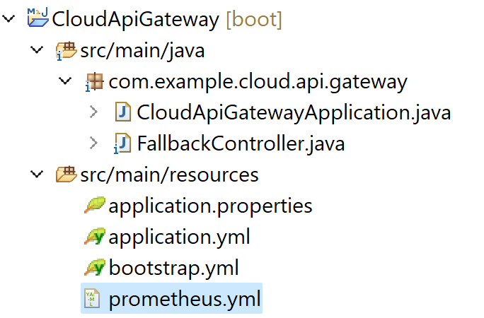

* 1. Add your Job Name

- job_name: "microservice app"

# metrics_path defaults to '/metrics'

# scheme defaults to 'http'.

scrape_interval: 2s

metrics_path: '/actuator/prometheus'

static_configs:

- targets: ["localhost:8989"]

* 1. Default location to open Prometheus is

Localhost:9090 in status tab you will find target option where

Your job name will be reflecting

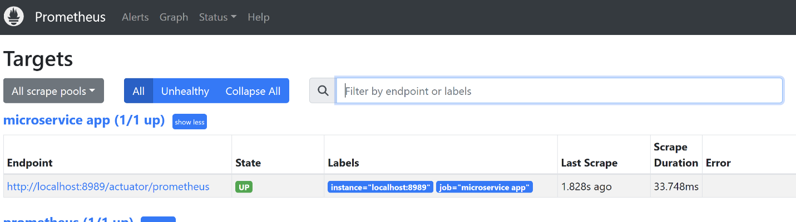

* 1. Also you can open localhost:8989/actuator/prometheus

|  |  |  |  |  |  |
| --- | --- | --- | --- | --- | --- |
|  |  |  |  |  |  |
|  |  |  | Order Service Payment Service Mailing Service Product Service Anlytics Services AI Based ( Visualization / AI  etc..) Ink Drawings Ink Drawings Ink Drawings Ink Drawings Ink Drawings Ink Drawings Ink Drawings Ink Drawings Ink Drawings Ink Drawings Ink Drawings Ink Drawings Ink Drawings Ink Drawings Ink Drawings Ink Drawings Ink Drawings Ink Drawings Ink Drawings Ink Drawings Ink Drawings Ink Drawings Ink Drawings Ink Drawings Ink Drawings Ink Drawings Ink Drawings Ink Drawings Ink Drawings Ink Drawings Ink Drawings Ink Drawings Ink Drawings Ink Drawings Ink Drawings Ink Drawings Ink Drawings Ink Drawings Ink Drawings Ink Drawings Ink Drawings Ink Drawings Ink Drawings Ink Drawings Ink Drawings Ink Drawings Ink Drawings Ink Drawings | | |
|  | Microservices       |  |  | | --- | --- | | Synchronously | Asynchronously | | It's easy to implement | Difficult due to message broker | | Easy to test /debug | Difficult to test /debug | | Blocking | Non-Blocking( queue) | | Waiting time | Fast | | High Coupling | Loose Coupling | | Reliable due to response | Non reliable due to no-response | |  |
|  |  |  |  |  |
|  |  |  | Asynchronous Comm. Being done via Two ways  -> Message Based (Rabbit MQ , Apache Kafka)  -> Call-Back |  |
|  |  |  |  |  |

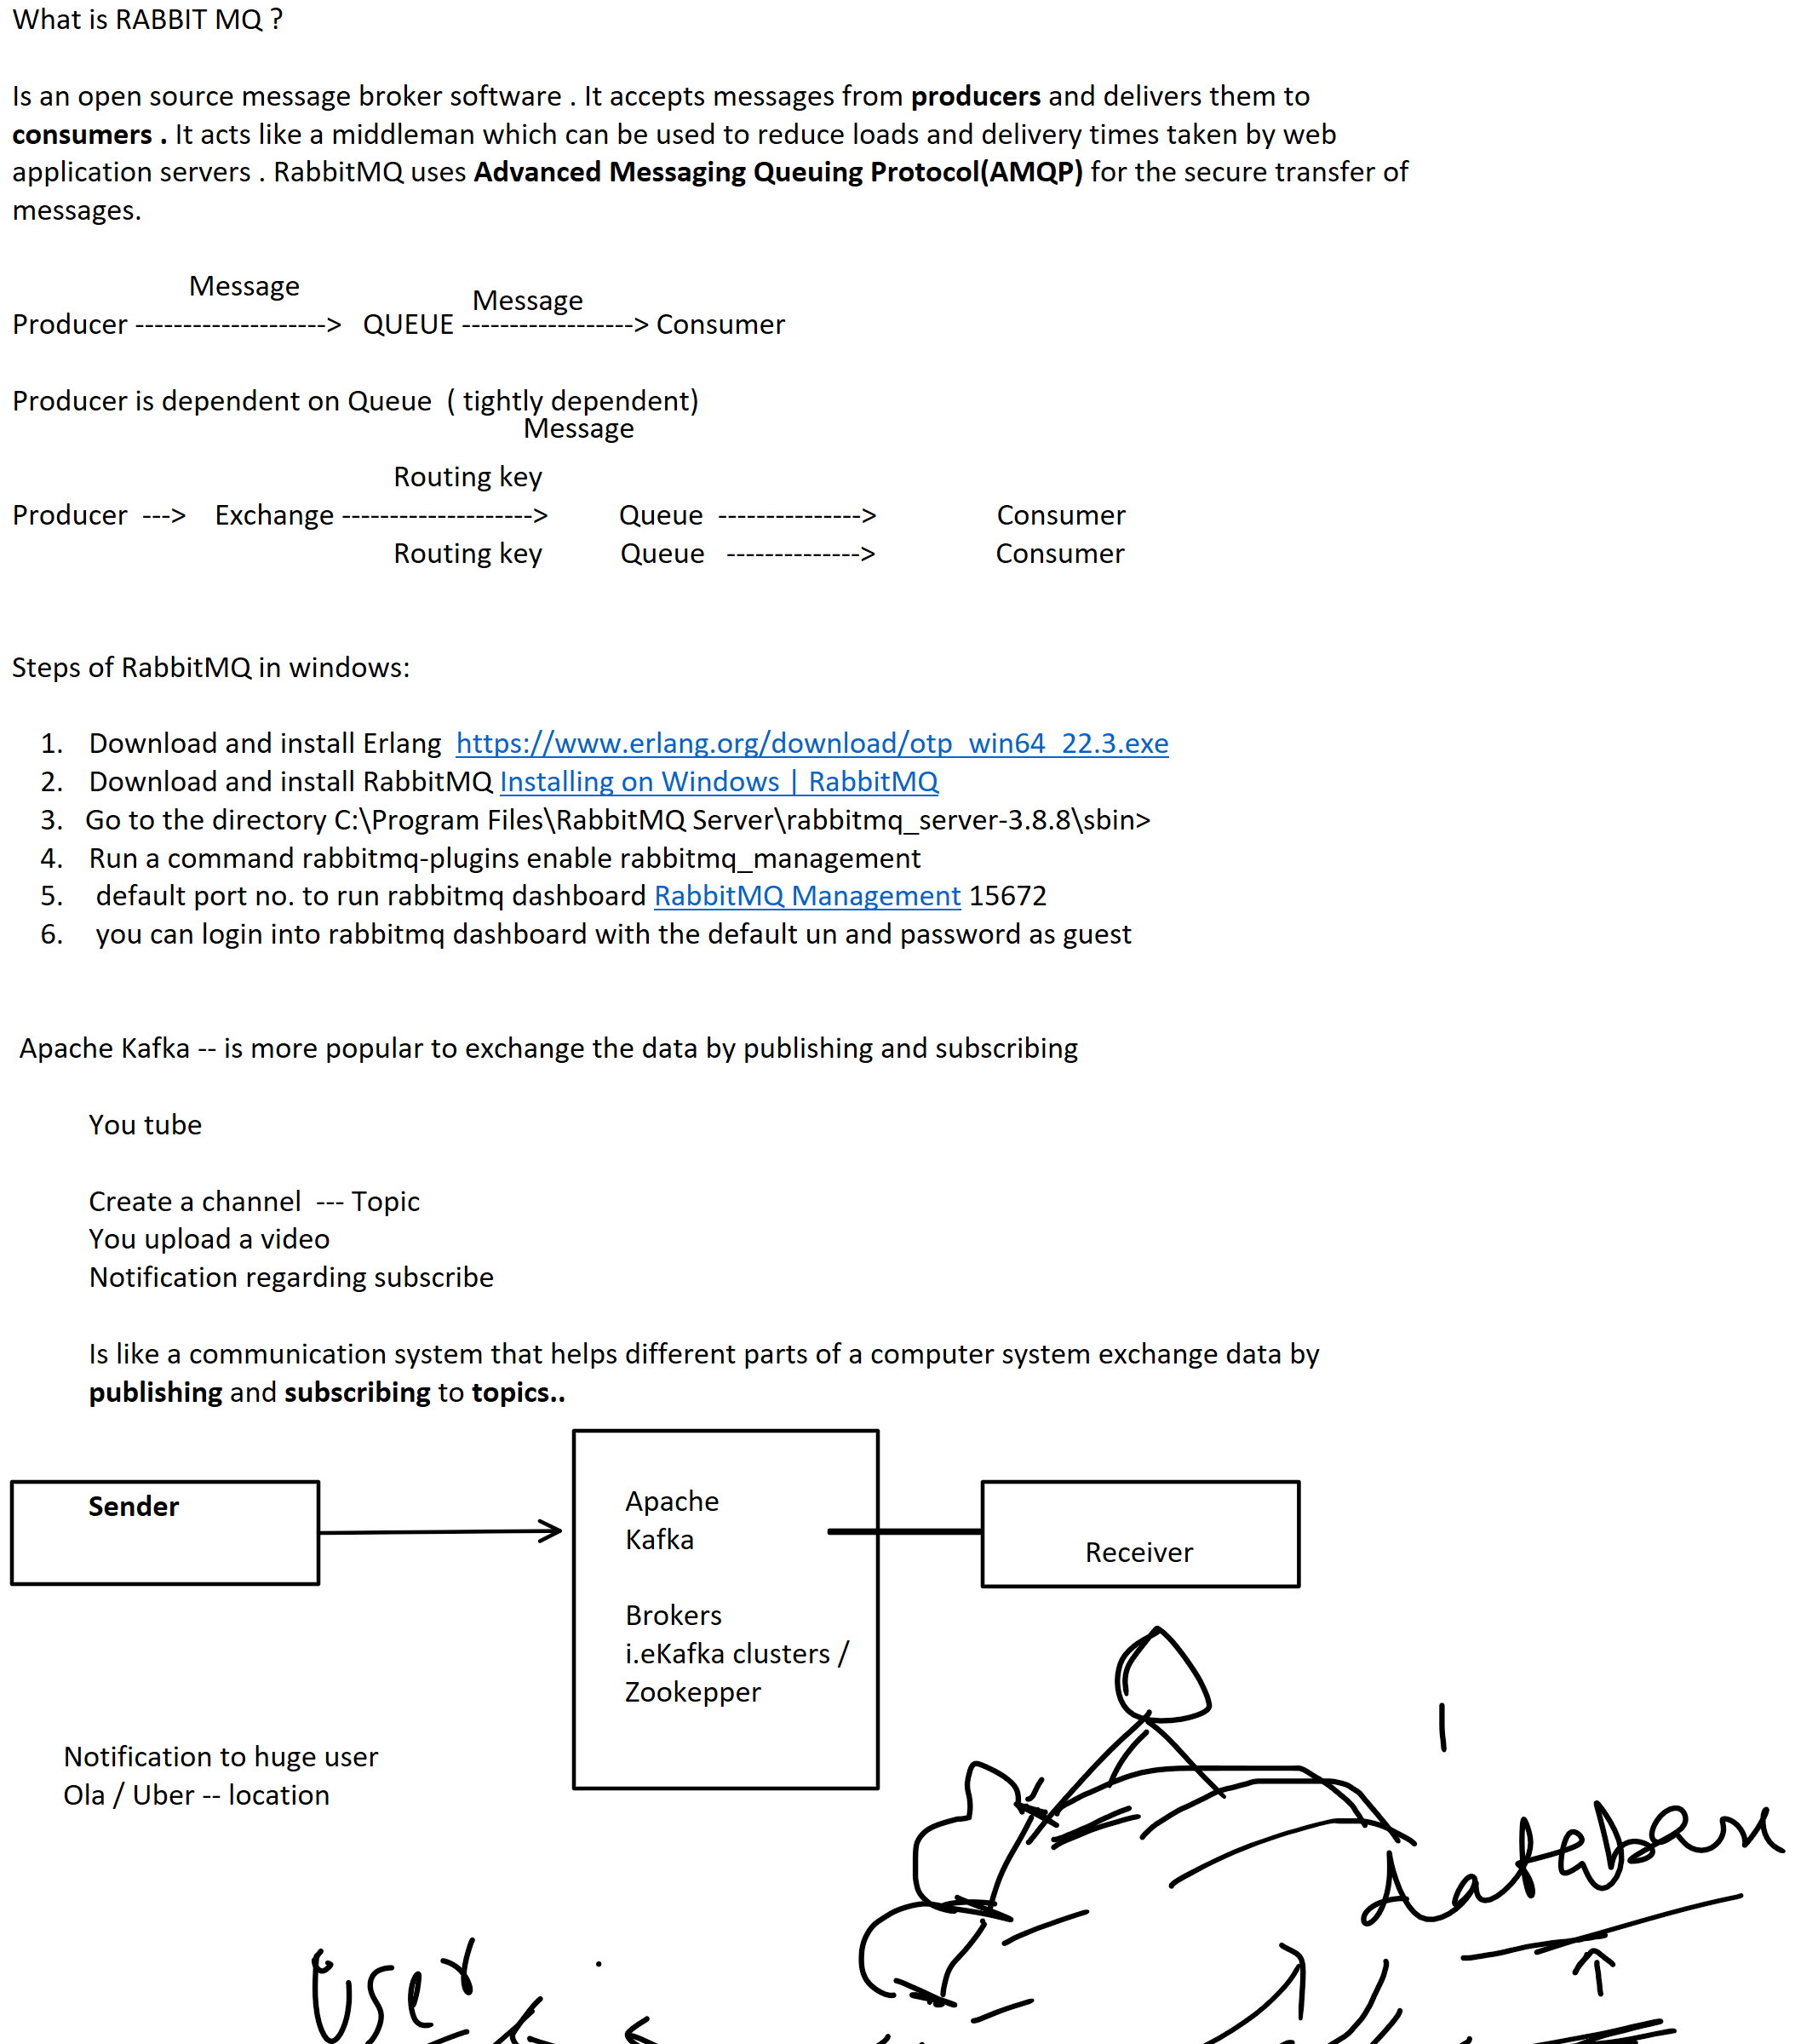  
Ink Drawings
Ink Drawings
Ink Drawings
Ink Drawings
Ink Drawings
Ink Drawings
Ink Drawings
Ink Drawings
Ink Drawings
Ink Drawings
Ink Drawings
Ink Drawings
Ink Drawings
Ink Drawings


Ink Drawings
Ink Drawings
Ink Drawings
Ink Drawings
Ink Drawings
Ink Drawings
Ink Drawings
Ink Drawings
Ink Drawings
Ink Drawings
Ink Drawings
Ink Drawings
Ink Drawings
Ink Drawings
Ink Drawings
Ink Drawings
Ink Drawings
Ink Drawings
Ink Drawings
Ink Drawings
Ink Drawings
Ink Drawings
Ink Drawings
Ink Drawings
Ink Drawings
Ink Drawings
Ink Drawings
Ink Drawings
Ink Drawings
Ink Drawings
Ink Drawings
Ink Drawings
Ink Drawings
Ink Drawings
Ink Drawings
Ink Drawings
Ink Drawings
Ink Drawings
Ink Drawings
Ink Drawings
Ink Drawings
Ink Drawings
Ink Drawings
Ink Drawings
Ink Drawings
Ink Drawings
Ink Drawings
Ink Drawings
Ink Drawings
Ink Drawings
Ink Drawings
Ink Drawings
Ink Drawings
Ink Drawings
Ink Drawings
Ink Drawings
Ink Drawings
Ink Drawings
Ink Drawings
Ink Drawings
Ink Drawings
Ink Drawings
Ink Drawings
Ink Drawings
Ink Drawings
Ink Drawings
Ink Drawings
Ink Drawings
Ink Drawings
Ink Drawings
Ink Drawings
Location
Ink Drawings
Ink Drawings


Why

Hight Throughput
Fault Tolerance
Durable
Sacalable
Ink Drawings
Ink Drawings
Ink Drawings
Ink Drawings
Ink Drawings
Ink Drawings
Ink Drawings
Kafka Ecosystem
Topic-A
Topic-B
Partition-A
Ink Drawings
Ink Drawings
Ink Drawings
Broker-1
Ink Drawings
Broker-2
Ink Drawings
Ink Drawings
Ink Drawings
Ink Drawings
Producer
Consumer
Zookepper
Ink Drawings
Ink Drawings
Kafka Cluster


Microservice -- We can make configuration centralized so that all

Microservices make an access of it and how we can dynamically change the

Credentials like user id and password .Registering the service on cloud consul instead of

Eureka server ..

Firstly we install consul on pc

We can centralize the configuration, we can make it global without adding hard code configuration

Mockito :-- Junit - 5

-framework - API Unit Testing// Simulate the behaviours of dependencies in testing the individual components

Powerful tool for writing clean , readable or testing by some components…

JUNIT

Some of the features of Mockito are given:

1. Mock Object:
2. Stubbing
3. ArgumentMatchers:---
4. Annotations : @Mock, @injectMocks,@SpringBootTest, @TestJpa
5. BDD - Jherkin Language : given , when , then
6. Integration with Junit

DOCKER :   (Container -- Image)

A way to package an application with all necessary dependencies and configuration.

Portable artifact, easily shared and moved around

Makes development and deployment efficient


Wrt application 
Installation process different on each OS Environment




Ink Drawings
Ink Drawings
Ink Drawings
Ink Drawings
Ink Drawings
Ink Drawings
Ink Drawings
Ink Drawings
Ink Drawings
Ink Drawings
Ink Drawings
Ink Drawings
Ink Drawings
Ink Drawings
Ink Drawings
Ink Drawings
Ink Drawings
Ink Drawings
Ink Drawings
Ink Drawings
Ink Drawings
Ink Drawings
Ink Drawings
Ink Drawings
Ink Drawings
Ink Drawings
Ink Drawings
Ink Drawings
Ink Drawings
Ink Drawings
Ink Drawings
Ink Drawings
Ink Drawings
Ink Drawings
Ink Drawings
Ink Drawings
Ink Drawings
Ink Drawings
Ink Drawings
Ink Drawings
Ink Drawings
Ink Drawings
Ink Drawings
Ink Drawings
Ink Drawings
Ink Drawings
Ink Drawings
Ink Drawings
Ink Drawings
Ink Drawings
Ink Drawings
Ink Drawings
Ink Drawings
Ink Drawings
Ink Drawings
Ink Drawings
Ink Drawings
Ink Drawings
Ink Drawings
Ink Drawings
Ink Drawings
Ink Drawings
Ink Drawings
Ink Drawings
Ink Drawings
Ink Drawings
Ink Drawings
Ink Drawings
Ink Drawings
Ink Drawings
Ink Drawings
Ink Drawings
Ink Drawings
Ink Drawings
Ink Drawings
Ink Drawings
Ink Drawings
Ink Drawings
Ink Drawings
Ink Drawings
Ink Drawings
Ink Drawings
Ink Drawings
Ink Drawings
Ink Drawings
Ink Drawings
Ink Drawings
Ink Drawings
Ink Drawings
Ink Drawings
Ink Drawings
Ink Drawings
Ink Drawings
Ink Drawings
Ink Drawings
Ink Drawings
Ink Drawings
Ink Drawings
Ink Drawings
Ink Drawings
Ink Drawings
Ink Drawings
Ink Drawings
Ink Drawings
Ink Drawings
Ink Drawings
Ink Drawings
Ink Drawings
Ink Drawings
Ink Drawings
Ink Drawings
Ink Drawings
Ink Drawings
Ink Drawings
Ink Drawings
Ink Drawings
Ink Drawings
Ink Drawings
Ink Drawings
Ink Drawings
Ink Drawings
Ink Drawings
Ink Drawings
Ink Drawings
Ink Drawings
Ink Drawings
Ink Drawings
Ink Drawings
Ink Drawings
Ink Drawings
Ink Drawings
Ink Drawings
Ink Drawings
Ink Drawings
Ink Drawings
Ink Drawings
Ink Drawings
Ink Drawings
Ink Drawings
Ink Drawings
Ink Drawings
Ink Drawings
Ink Drawings
Ink Drawings
Ink Drawings
Ink Drawings
Ink Drawings
Ink Drawings
Ink Drawings
Ink Drawings
Ink Drawings
Ink Drawings
Ink Drawings
Ink Drawings
Ink Drawings
Ink Drawings
Ink Drawings


What is container?

Layers of images
Mostly linux base Image, because small in size
Appln image is on top of linux base image
Ink Drawings
Ink Drawings
Ink Drawings
Ink Drawings
Ink Drawings
Ink Drawings
Ink Drawings
Ink Drawings
Ink Drawings
Ink Drawings
Ink Drawings
Ink Drawings
Ink Drawings
Ink Drawings
Ink Drawings
Ink Drawings
Ink Drawings
Ink Drawings
Ink Drawings
Ink Drawings
Ink Drawings
Ink Drawings
Ink Drawings
Ink Drawings
Ink Drawings
Ink Drawings
Ink Drawings
Ink Drawings
Ink Drawings
Ink Drawings
Ink Drawings
Ink Drawings
Ink Drawings
Ink Drawings
Ink Drawings
Ink Drawings
Ink Drawings
Ink Drawings
Ink Drawings
Ink Drawings
Ink Drawings
Ink Drawings
Ink Drawings
Ink Drawings
Ink Drawings
Ink Drawings
Ink Drawings
Ink Drawings
Ink Drawings
Ink Drawings
Ink Drawings
Ink Drawings
Ink Drawings
Ink Drawings
Ink Drawings
Ink Drawings
Ink Drawings
Ink Drawings
Ink Drawings
Ink Drawings
Ink Drawings
Ink Drawings
Ink Drawings
Ink Drawings
Ink Drawings
Ink Drawings
Ink Drawings
Ink Drawings
Ink Drawings
Ink Drawings
Ink Drawings
Ink Drawings
Ink Drawings
Ink Drawings
Ink Drawings
Ink Drawings
Ink Drawings
Ink Drawings
Ink Drawings
Ink Drawings
Ink Drawings
Ink Drawings
Ink Drawings
Ink Drawings
Ink Drawings
Ink Drawings
Ink Drawings
Ink Drawings
Ink Drawings
Ink Drawings
Ink Drawings
Ink Drawings
Ink Drawings
Ink Drawings
Ink Drawings
Ink Drawings
Ink Drawings
Ink Drawings
Ink Drawings
Ink Drawings
Ink Drawings
Ink Drawings
Ink Drawings
Ink Drawings
Ink Drawings
Ink Drawings
Ink Drawings
Ink Drawings
Ink Drawings
Ink Drawings
Ink Drawings
Ink Drawings
Ink Drawings
Ink Drawings
Ink Drawings
Ink Drawings
Ink Drawings
Ink Drawings
Ink Drawings
Ink Drawings
Ink Drawings
Ink Drawings
Ink Drawings
Ink Drawings
Ink Drawings
Ink Drawings
Ink Drawings
Ink Drawings
Ink Drawings
Ink Drawings
Ink Drawings
Ink Drawings
Ink Drawings
Ink Drawings
Ink Drawings
Ink Drawings
Ink Drawings
Ink Drawings
Ink Drawings
Ink Drawings
Ink Drawings


Ink Drawings
oAuth 

12 factors cloud app , microservices design pattern



Create a Pizza Store

1. Admin
2. User

Admin Stories

1. Able to login and logout into the application
2. Able to perform the CRUD on the items available in the menu
3. Can accept or reject the order from the users
4. Should be able to generate the bill of a particular user
5. able to see the monthly revenue of the shop.

User stories

1. Should be able to register , login and logout
2. should be able to see the different categories of the menu like pizza , beverages, new launches.
3. Should be able select one or more items from that category
4. Once the order is place user should be able to receive message …
5. Should be able to see the bill amount for the order along with payment options.
6. Mode of delivery

Instructions:

1. Databases
2. Create entities
3. Microservices
4. Notification service
5. Payment service
6. Order service
7. Swagger
8. JWT
9. Security / Spring cloud config

JENKINS : --- CI/CD tool --- set the time periodically ,, for a certain time period it will automatically rebuild the project / JOB - freestyle / Pipeline jdk /maven /pull the project from git SCM / push it to the docker .

Install plugins-- JDK , MAVEN & Docker